[1]

Assignment 2 – Binary Mastermind

Yvan Gihoza

***Overview*—The second assignment was to give us a practice with designing state machines and convert them into C code. We had to use the RIMS microcontroller simulator.**

1. INTRODUCTION

T

He game had 8 inputs being the A vector and we had to create a C header file containing the secret code. The user or the player had to try and guess the code in 10 tries by pushing the C button as to send the input and compare it to the code. The B vector was acting like LEDs where different blinking meant different operations. 3 quick blinking to show the game had started and going through the LEDs for waiting the input, B0-B3 quickly five times for wining and B4-B7 for losing.

1. Application Design

I started by designing the state machines on a paper to get a better view and approach. My design has 3 state machines, one controlling the LEDs blinking, another for the C debounce and pressing and a last one to check the input and tell the user if they won or not.

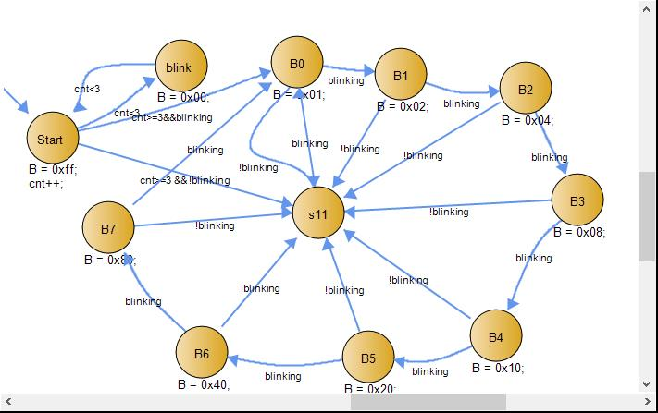

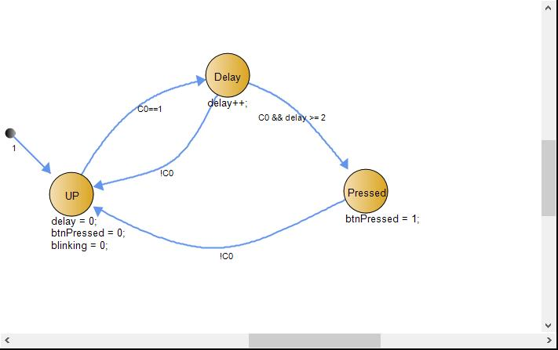

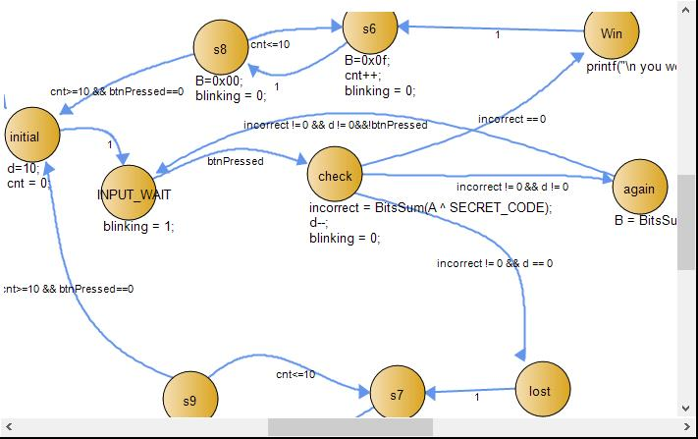

1. Results

I had some trouble with the header secret code file as my design was not finding the path, so I had to use a global variable for that. I also used a variable D initialized to 10 and decrement on every try. My game was designed as after winning B0-B3 blinks a bunch of time and then goes back to the waiting of input state were all the lights were blinking one by one respectively, it was the same thing for losing but B4-B7 were the ones blinking.

.

1. Conclusion

My project was a success since I was able to implement all the main objective required, I had some trouble with the header file and some other couple issues but I was able to go around them and finish it.

1.